*LAB # 03*

REcursion

# *OBJECTIVE:*

*To understand the complexities of the recursion function and a way to reduce these complexities*

*LAB task*

1. *Write a program which takes an integer value (k) as input and prints the sequence of numbers from k to 0 in descending order..*

**Code:**

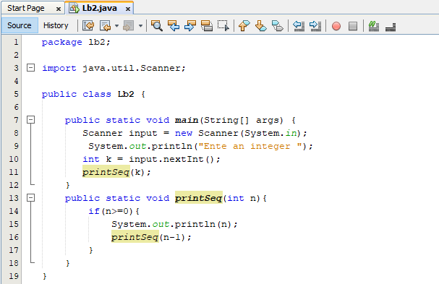

**Output:**

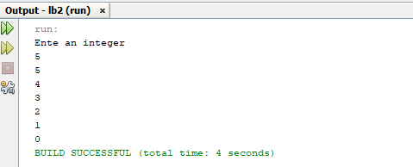

1. *Write a program to reverse your full name using Recursion.*

**Code:**

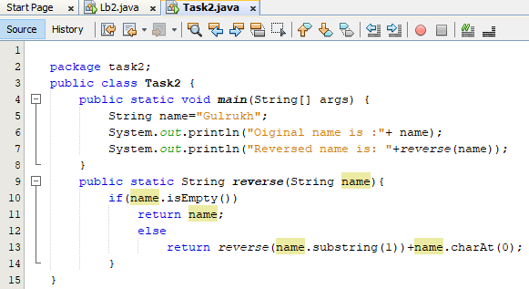

**Output:**

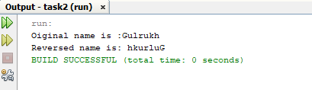

1. *Write a program to calculate the sum of numbers from 1 to N using recursion. N should be user input.*

**Code:**

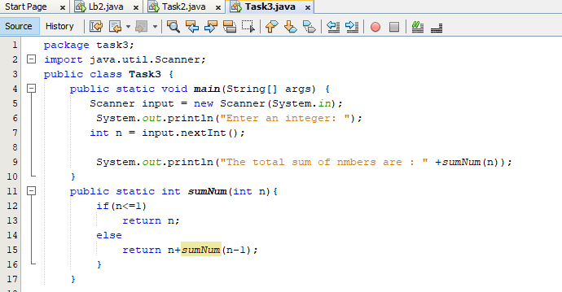

**Output:**

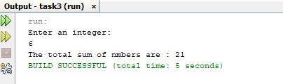

1. *Write a recursive program to calculate the sum of elements in an array.*

**Code:**

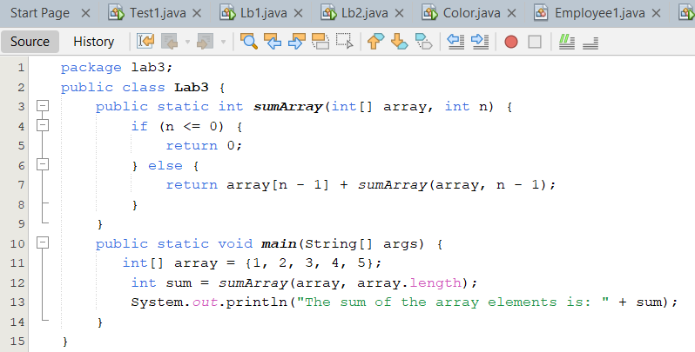

**Output:**

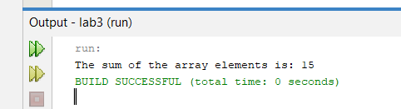

1. *Write a recursive program to calculate the factorial of a given integer n*

**Code:**

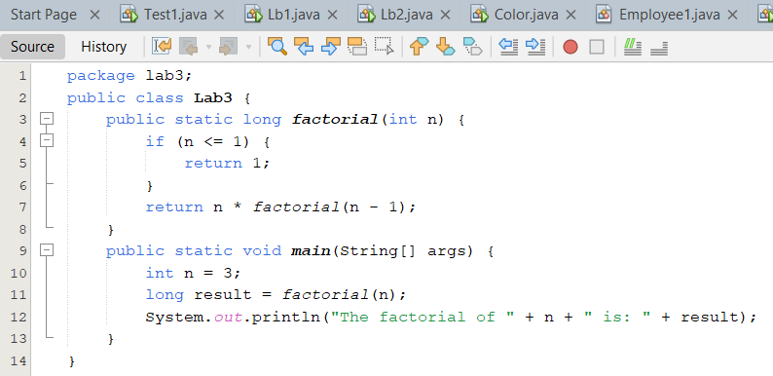

**Output:**

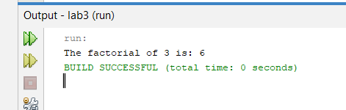

1. *Write a program to count the digits of a given number using recursion.*

**Code:**

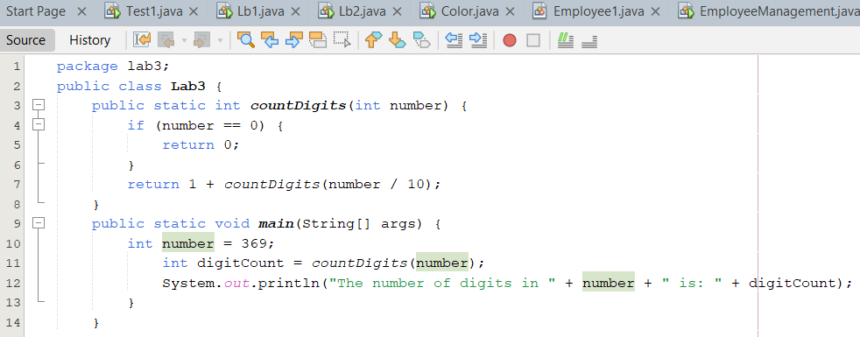

**Output:**

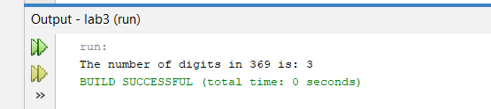

*HOME task*

1. *Write a java program to find the N-th term in the Fibonacci series using Memoization*

**Code:**

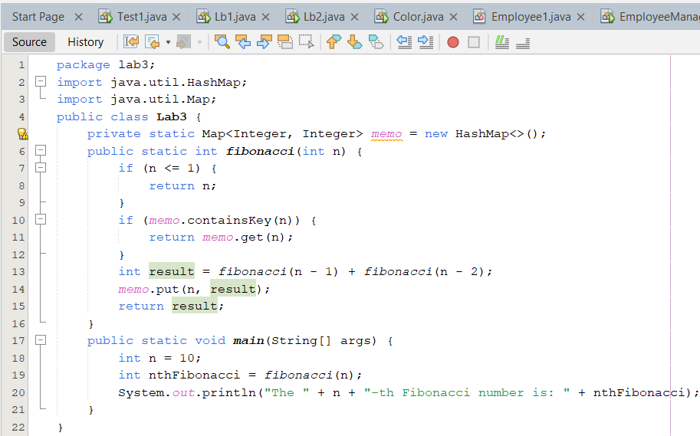

**Output:**

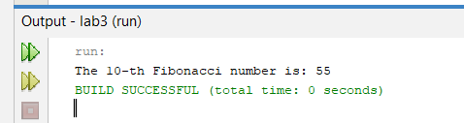

1. *Write a program to count the digits of a given number using recursion*

**Code:**

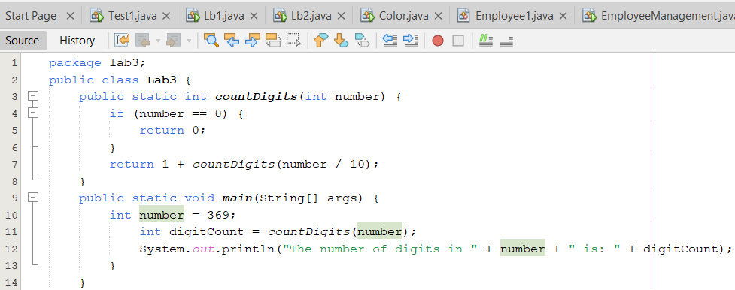

**Output:**

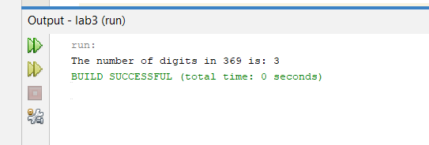

1. *Write a java program to check whether a given string is a palindrome or not. A palindrome is a string that reads the same forwards and backwards.Print "YES" if the string is a palindrome, otherwise print "NO"..*

**Code:**

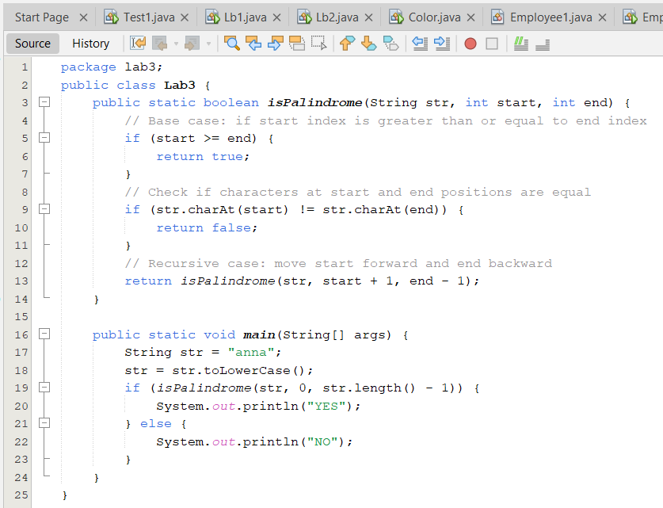

**Output:**

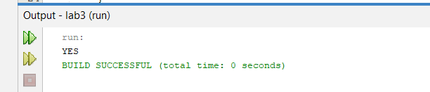

1. *Write a recursive program to find the greatest common divisor (GCD) of two numbers using Euclid's algorithm.*

**Code:**

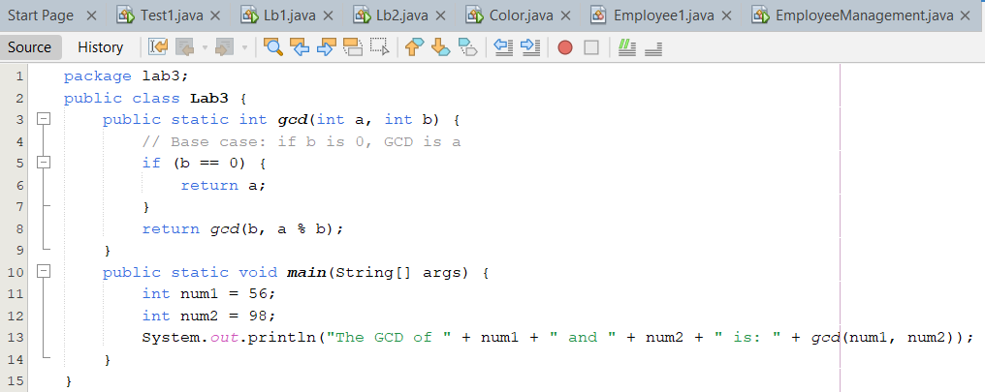

**Output:**

